Team 5 Project Plan

Good News Outreach Website Redesign
Morgan Elizabeth, Alexander Garcia, Ryan Lanes, Adam McCall

December 1st, 2015

Executive Summary
The project team was assigned to create a new webpage for Good News Outreach. From the beginning of the September we have been working closely with the project sponsor Carla McClellan, who was very helpful throughout the entire process. Ms. McClellan had made it very clear that was not an option to change the domain name. If we could not transfer the existing name we will have to work with CityMax when making any changes to the web site. After finding the web host Wix, where we were able to keep the domain name, the team was able to get started.

During the first meeting with Ms. McClean, the team had agreed on the definite changes that were needed on the website. GNO requested the following an active calendar, links to social media account, easy donation (PayPal link, credit card) and a modern look. Taking into consideration everything they had requested the team created multiple different mock up designs we then showed Ms. McClean.

The beginning stages the project team had schedule a meeting once every week with Ms. McClellan to make sure we were able to accomplish every detail GNO wanted. After receiving that information the project team went on to plan the schedule for the next 5 months. The planning period, executing, and finally presentation of the final outcome. The team is still working on the last details for the new website and are planning to show Ms. McClellan the final product 12/3/15.

The project team was given a budget of $50/month to find a new web host. GNO was currently paying $30/month for CityMax, the team had come to the conclusion that there are more affordable web hosts that was user friendly and had more features. After weeks of research the team had found Wix, a web host that is $15/month with the features our team was looking for. Ms. McClellan was more than happy we were able to cut what they were currently paying for in half.

Project risks the team and GNO could run into now and in the future can create major issues for everyone. A few examples of the major risks that could occur would be if the web host were to go out of business, the webhost were to redesign the website, and the most important one was scheduling conflicts between the team and GNO. All of these would create a great deal of problems for the future.

Working with a group can be hard at times but through communication we were able to make this project flow smoothly. The project team communicated through a facebook group and text message, while our team leader would contact Ms. McClellan through email. These ways of communication had worked perfectly with everyone's busy schedules.

The project team is finalizing the new website and waiting on the approval from GNO to transfer everything. Once we get the approval to transfer the website, the project team will have completed everything that was asked of us from Good News Outreach.
Section 1: Introduction and Project Charter

Introduction
Our group has been assigned with redesigning the current website for the local organization Good News Outreach. In doing so we hope to create a more modern and better organized website layout while maintaining the original website’s integrity as a local faith-based community. Completing this task will require that we keep in contact with our project sponsor, Clara McClellan, at least once every week to ensure that everything is going according to plan. In this time we will also present to her a series of prototype designs before submitting a final design, thus guaranteeing a satisfactory end result.

Resources
For this project we worked in a team of four people and our client gave us a budget of $50 per month to work with for webhosting and website design. Equipment was up to our discretion on what to use. The most limited resource that we had was time. The team worked on a timetable where certain portions of the project were due every other week. At the project start we had available to us all of our client’s previous website information as well as their account information and access for their old webhost.

Schedule Expectations
The project was expected to be completed in phases. Some of the earlier phases were setting up the framework of the project by selecting a new webhost. Early on the team was also expected to submit designs for the website. Every other week there was some deliverable to present to our sponsor or some status report to give. Face to face meetings happened only a few times over the project duration. The project is expected to be completed by the end of the year, assuming the client’s other employers meet their deadlines.

Goal Breakdown Structure
The team has four major goals for this project:

- Select a new webhost and migrate the client’s website to the new host
- Develop a design for the new website and have it approved
- Implement the new website on the new webhost
- Train the client’s staff on how to update the new website

Scope
- First, and most importantly, the project team was to design three different potential web page layouts for Clara to critique. These rough designs were due on Monday, Oct. 12th.
- Second, the new layout should also make the donate option much more prominent. The current link to the donation page is too difficult to navigate to and will therefore simply be placed on the homepage.
- Lastly, our team should have conducted research to find a more affordable and versatile web-hosting service.

Assumptions and Constraints
We were given a list of expectations that the new website needed to meet. Some of these expectations were a more friendly paypal link, holding onto the client’s current domain name and email addresses, and setting up a more user-friendly calendar on the site. Other than these expectations, it was assumed that the overall look and feel of the site would be changed from the archaic design that they were using to a more modern design. The client instructed us to look at a few similar sites from other charity organizations to use as a reference when designing the new site.

Section 2: Project Activities and Work Breakdown Structure

Major Activities and Tasks

Webhost
The project team first had to select a new webhost. The old host, City Max, did not meet the needs of our client. Our budget was $50 to find a new host where the client could specifically update the website through the new web host's software as opposed to uploading the files to the host’s server. We selected Wix which met all of our needs and had a cost of $15 per month to use, cutting our client’s current bill in half. Wix’s software to update the website is intuitive and easy to use.

Website Design
For this portion of the project the team was to present two to three designs to the client of the new website. The client would then pick and choose from the features that we provided to them so that we could implement those features in the final webpage. One of the designs we gave them was a mock website on squarespace with an example homepage and about page. The second design was an early conceptualization of a paper-based layout. This layout had different features on it that would be more timely to present to the client in a paper form and have them choose one or the other for implementation.

Website Implementation
This step is a relatively simple one. After the new webhost was selected and paid for, the project team was responsible for migrating the old website to the new server. Furthermore, after the new website was designed and ready for implementation, it would be uploaded in replacement of the client’s old site.

Training
This is the final part of the process. As our client has no specialist for web design and development, we would need to train our sponsor on Wix’s software so that she could update the site with new information. This step would insure that the client could maintain the new website without any extra outside assistance.

Section 3: Project Schedule

Milestones, Activities, and Issues
With our schedule the project team had no problem meeting our deadlines. In most cases what was expected of us from our sponsor preceded what was required for the course which made meeting course requirements easy. The only holdup that the project team had as a whole was towards the end of the project. Our work is reliant on the client’s own IT employee to finish some of the backend migration to the new webhost. Because that work has yet to be completed, our implementation of the new website is delayed.

Section 4: Budget

Cost Estimate
Taking the elements that we have added to the new site, competitor quotes were gathered to determine approximately how much a website redesign would cost if the work was outsourced. The lowest estimate gathered was $1,500 with the highest being $6,000. Assuming that the site was a redesign as well as most of the materials being provided, that would lower the cost by some degree. The actual cost may be around $2,250 for the design (+$15/ month for a webhost).

Our team had a budget of $50 per month in order to secure a web hosting agency for our client. We cut their current costs in half from $30 to $15. The lowest costing webhost that we found was approximately $5 per month, but this site did not have the interface required for our client to easily update the site themselves when they saw fit. If they were to hire a person to work monthly we estimated it to cost more than the $10 difference each month so we decided to go with the $15 a month option.

Besides the initial development cost, the only maintenance cost would be paying for the domain name and the webhost. There is no additional costs in equipment or personnel that need be taken care of; neither by our team nor the client’s staff.

Section 5: Risk Management Plan
The highest priority during our time working with Good News Outreach is to submit all final designs and account information to them before the due date at the end of the semester. Therefore, this possible risk is rated the highest within the project teams risk register. Both GNO and the project team would suffer from this event as they would have wasted nearly five months working on a project with no achievement and the team would most likely not receive a passing grade for this course.
One of the more likely but less damaging risks to happen during the project is the inability to contact all stakeholders in a timely and convenient method. Thus far, Ms. McClellan has strictly been emailing the team leader which is then passed on to the rest of the group via social media or text message. This has proven to be a slight issue seeing as multiple methods of communication are being employed while the entire project team and GNO could suffice with just one. This risk has not affected the quality or timeliness of our deliverables although it has made the communication process more complicated than necessary.

Other risks include the website host going down, GNO could no longer afford to pay for the web host, and device compatibility. These all have to do with the web host and GNO and all would occur in the future when the project team is no longer involved. The project team thought about what web host would work best for GNO with the intentions of never having to deal with these problems in the future, the reason the team chose Wix.

Section 6: Communication Plan
Ms. McClellan was the only person we were in contact with throughout the project while working with GNO. We communicated with Ms. McClellan every other week. Each meeting revolved around an agenda item that was assigned to be completed at the previous meetings. The project team had status reports on the project as well as the material that we have completed up to the point of the meeting. The project team was in constant contact with Ms. McClellan by email. After meeting the project team and Ms. McClellan would set dates when to meet again and show the progress with the website for the next couple of weeks.

Ryan Lanes, Adam McCall, Alex Garcia, Morgan Geller are all members included in this project team. The team is communicating constantly throughout the week to make sure that everything is in order and we are all on the same page when going into meetings, or making changes to any part of the project. The members who attend the scheduled class meetings also gather afterwards to discuss project updates and progress. Group members are in contact with one another through various outlets. The team communicates primarily through the facebook group made specifically for this project. Team members have also exchanged phone numbers and email addresses in case one of our members cannot be reached through social media.

Appendix:

Work Breakdown Structure and Gantt Chart
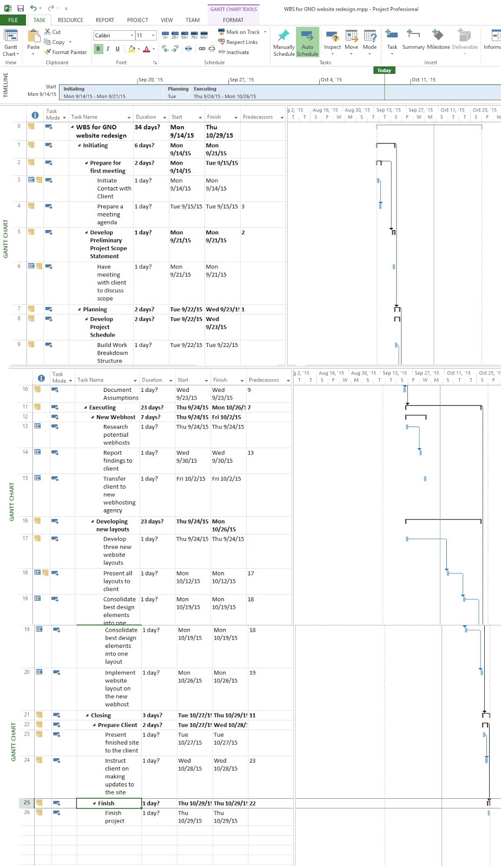

Risk Register

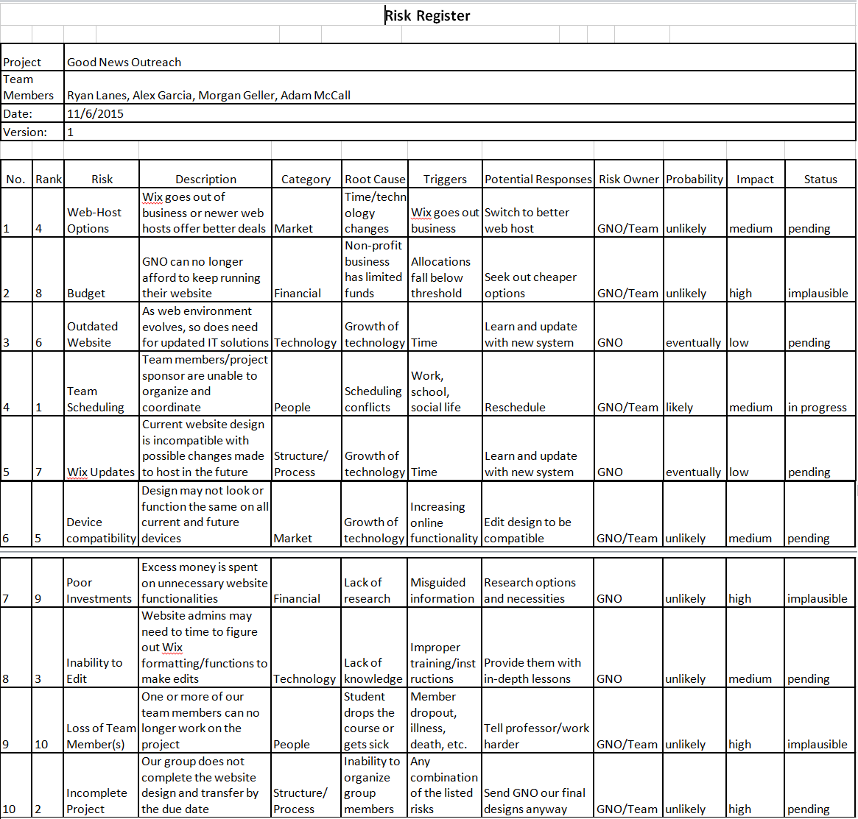

Communication Examples

